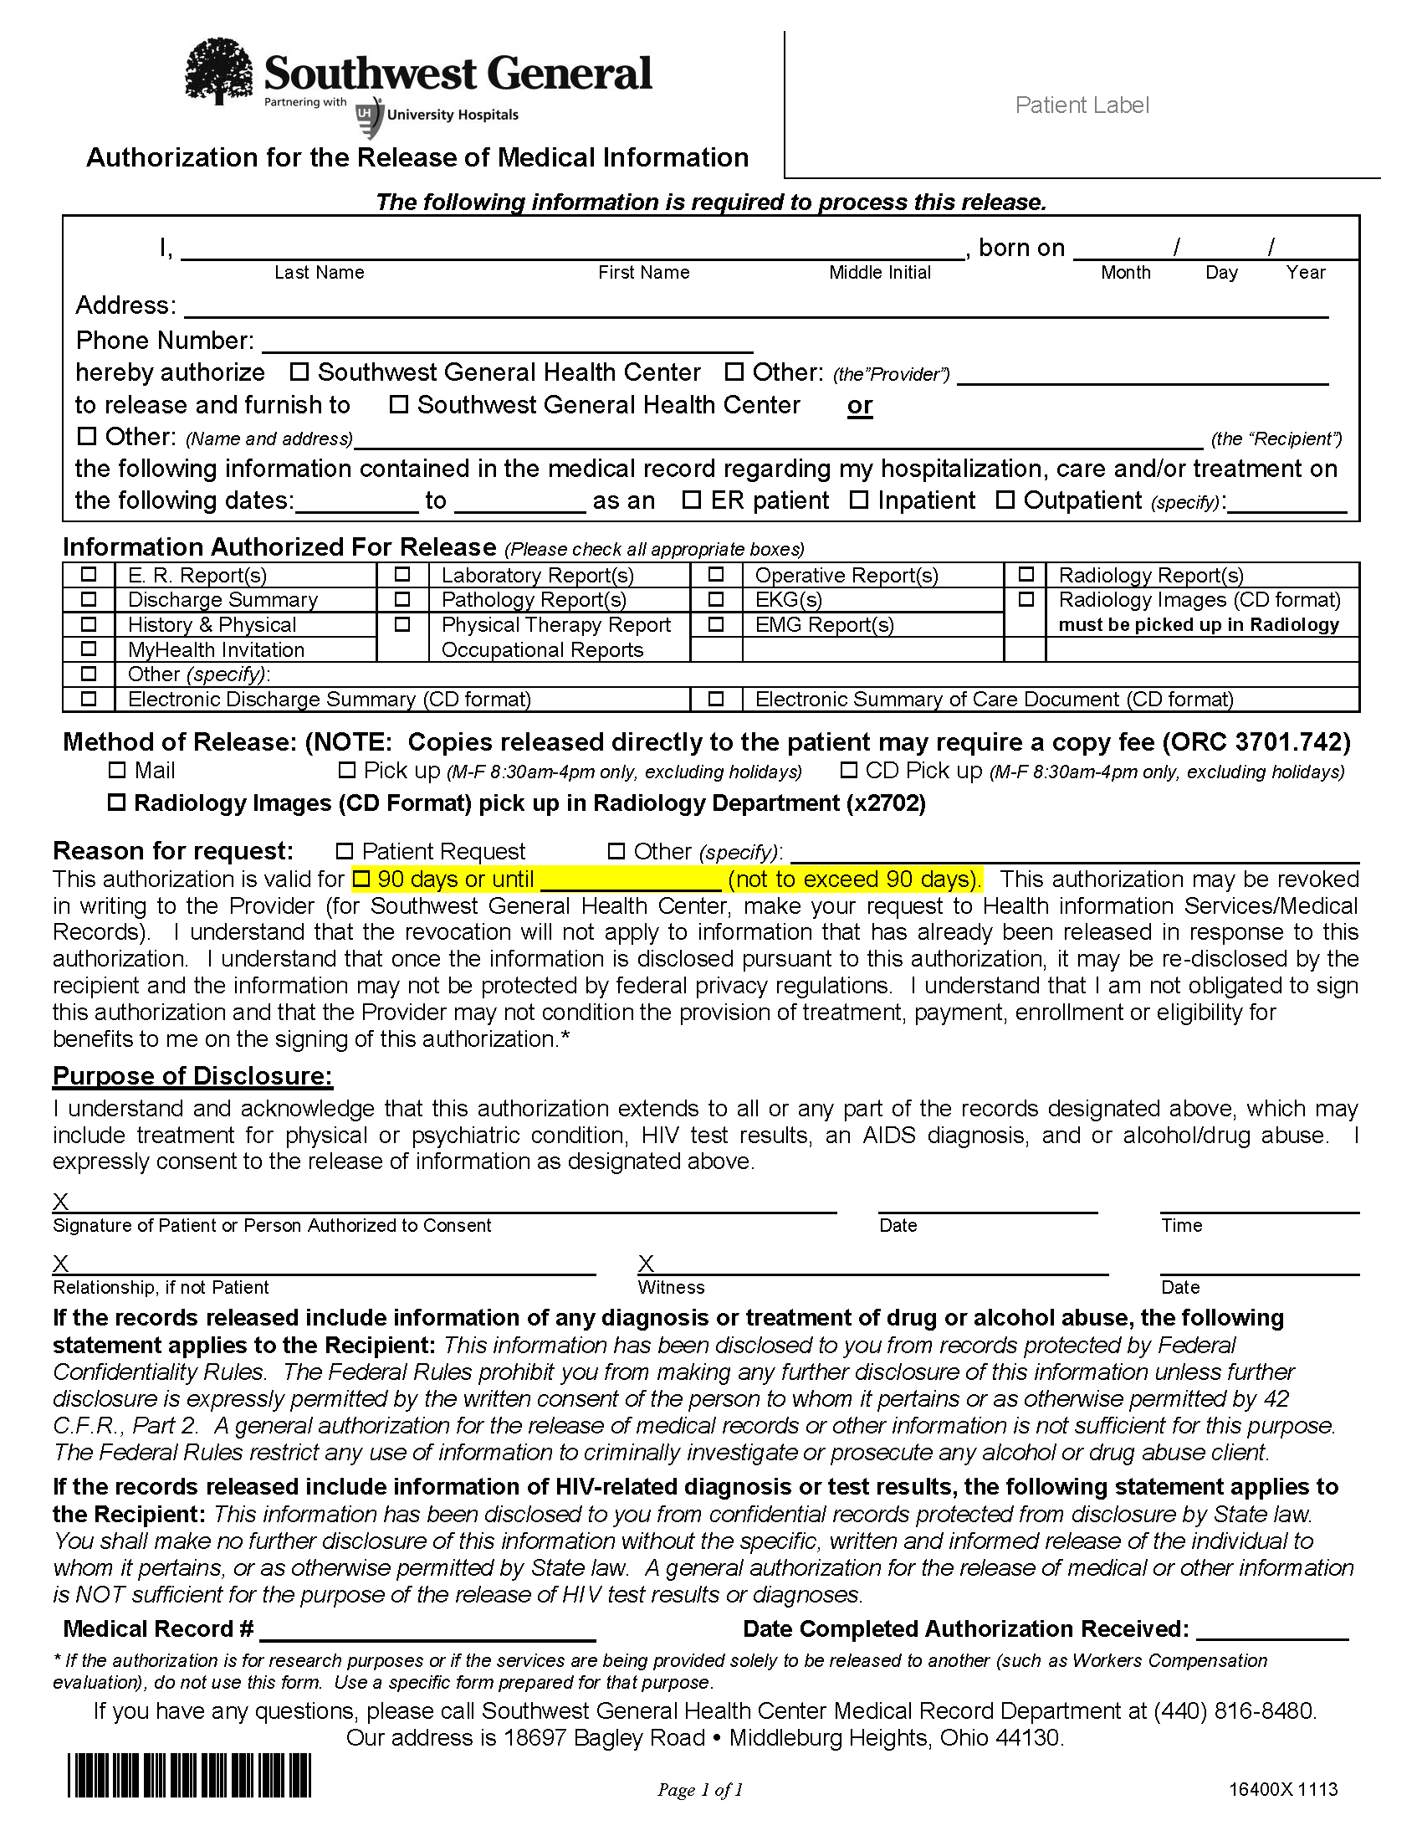
Batman
01/01/1979
Axiom Requisition Copy Service 2869 Jolly Road Okemos, MI 48864

X
FROM 01/01/1979 TO PRESENT: Any and all MEDICAL RECORDS, including but not limited to patient history form(s), reports, etc. pertaining to Batman SSN: xxx-xx-5555, DOB: 01/01/1979.

See Below
X

X
X
Litigation
End of Litigation

